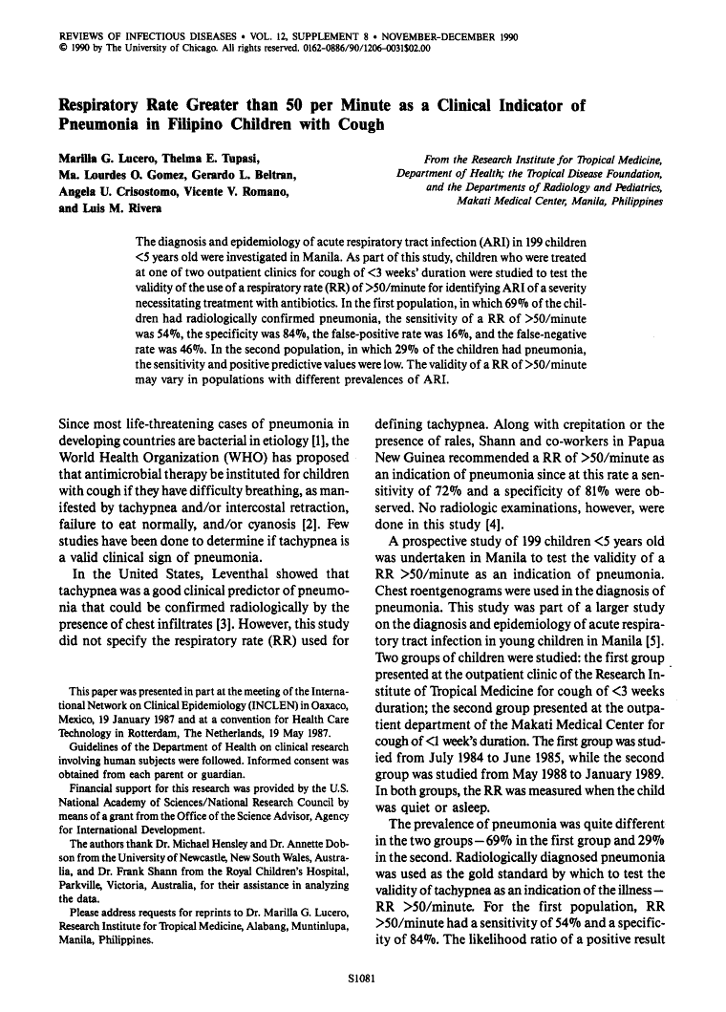

**Clinical signs of pneumonia in children attending a hospital outpatient department in Lesotho.**

[Redd SC](http://www.ncbi.nlm.nih.gov/pubmed?term=Redd%20SC%5BAuthor%5D&cauthor=true&cauthor_uid=8131246), [Vreuls R](http://www.ncbi.nlm.nih.gov/pubmed?term=Vreuls%20R%5BAuthor%5D&cauthor=true&cauthor_uid=8131246), [Metsing M](http://www.ncbi.nlm.nih.gov/pubmed?term=Metsing%20M%5BAuthor%5D&cauthor=true&cauthor_uid=8131246), [Mohobane PH](http://www.ncbi.nlm.nih.gov/pubmed?term=Mohobane%20PH%5BAuthor%5D&cauthor=true&cauthor_uid=8131246), [Patrick E](http://www.ncbi.nlm.nih.gov/pubmed?term=Patrick%20E%5BAuthor%5D&cauthor=true&cauthor_uid=8131246), [Moteetee M](http://www.ncbi.nlm.nih.gov/pubmed?term=Moteetee%20M%5BAuthor%5D&cauthor=true&cauthor_uid=8131246).

**Source**

Malaria Branch, Centers for Disease Control, Atlanta, GA 30333.

**Abstract**

To determine the value of clinical findings for the diagnosis of pneumonia, we evaluated 950 children who presented with respiratory illness to the outpatient department of the Queen Elizabeth II Hospital, Maseru, Lesotho. Those children at high risk for pneumonia and a systematically selected 20% sample of children at low risk were examined in turn by a nurse, a general practitioner, and a paediatrician; a chest radiograph was recorded for each child. Pneumonia was defined as radiographic findings compatible with the disease as interpreted by a paediatric radiologist. A respiratory rate > or = 50 breaths/minute was a sensitive sign for pneumonia among infants (sensitivity range for the three examiners: 59-79%), but identified a progressively smaller proportion of children with pneumonia in older age groups. Adjusting the respiratory rate for age using a threshold of > or = 40 breaths/minute for children aged > or = 12 months improved the sensitivity, but identified < 30% of children with pneumonia aged > or = 24 months. No drop in sensitivity with age was found when respiratory rate thresholds were evaluated for children with more severe radiographic evidence of pneumonia.

**PIP:**

Acute respiratory infections (ARI) are the root cause of more than 4 million child deaths annually. While the timely delivery of the full course of immunization does much to thwart ARI mortality, many children still contract pneumonia and need to be treated with antimicrobial drugs. Proper case management, however, depends upon whether pneumonia is accurately and timely diagnosed. The authors assess the value of clinical findings for the diagnosis of pneumonia from evaluations of 950 children presenting with respiratory illness to the outpatient department of the Queen Elizabeth II Hospital in Maseru, Lesotho. Findings obtained by a nurse, a general practitioner, and a pediatrician are also compared to shed light upon the relative values of their respective observations. Children at high risk for pneumonia were examined along with those in a systematically selected 20% sample of children at low risk. A chest radiograph was recorded for each child. Pneumonia was defined as a condition represented in the radiographic findings compatible with the disease as interpreted by a pediatric radiologist. The study found a respiratory rate of more than or equal to 50 breaths/minute to be a sensitive sign for pneumonia in infants; sensitivity among the examiners was in the range of 59-79%. Sensitivity did, however, increase for children aged 12 months or older when the respiratory rate was adjusted for age using a threshold of more than or equal to 40 breaths/minute, but less than 30% of children aged 24 months or older with pneumonia were identified. No decline in sensitivity with age was observed when respiratory rate thresholds were evaluated for children with more severe radiographic evidence of pneumonia. The authors therefore conclude that a respiratory rate thresholds of 50 breaths/minute may suffice to identify children with severe pneumonia. Sensitivity can always be increased by using an age-adjusted respiratory rate threshold.

[Pediatr Infect Dis J.](http://www.ncbi.nlm.nih.gov/pubmed/7715990) 1995 Jan;14(1):48-50.

# Respiratory rate and signs in roentgenographically confirmed pneumonia among children in China.

[Dai Y](http://www.ncbi.nlm.nih.gov/pubmed?term=Dai%20Y%5BAuthor%5D&cauthor=true&cauthor_uid=7715990), [Foy HM](http://www.ncbi.nlm.nih.gov/pubmed?term=Foy%20HM%5BAuthor%5D&cauthor=true&cauthor_uid=7715990), [Zhu Z](http://www.ncbi.nlm.nih.gov/pubmed?term=Zhu%20Z%5BAuthor%5D&cauthor=true&cauthor_uid=7715990), [Chen B](http://www.ncbi.nlm.nih.gov/pubmed?term=Chen%20B%5BAuthor%5D&cauthor=true&cauthor_uid=7715990), [Tong F](http://www.ncbi.nlm.nih.gov/pubmed?term=Tong%20F%5BAuthor%5D&cauthor=true&cauthor_uid=7715990).

### Source

Capital Institute of Pediatrics, Beijing, People's Republic of China.

### Abstract

A clinical study was conducted in three Chinese community hospitals to investigate the reliability of respiratory rate and various clinical signs in the diagnosis of pneumonia among 54 children less than 5 years of age. Anteroposterior chest film was used as the diagnostic standard. The cutoff criterion for rapid breathing was 50 breaths/minute for infants ages 2 to 11 months and 40/minute in children 1 to 5 years old. Rapid breathing was a better predictor of pneumonia than rales (positive predictive values of 74.5 and 66.9%). Nasal flaring, chest indrawing, stridor and cyanosis of the tongue had predictive values of > 86%, but these clinical signs were observed in only a small proportion of patients. We recommend that village health workers use rapid breathing for diagnosis of pneumonia, rather than auscultation which is difficult and has proved unreliable. Sensitivity, specificity and positive and negative predictive values are presented for seven signs and symptoms of pneumonia.

#### PIP:

During October 1989 to March 1990 pediatricians and radiologists conducted a clinical study in Shunyi, Nanbu, and Shifang County Hospitals, China, of 160 healthy children and 541 children with fever and cough to examine the reliability of respiratory rate and various clinical signs in the diagnosis of radiologically confirmed pneumonia among 54 children under 5 years of age. The mean respiratory rate among children with cough and fever was 50 breaths/minute for infants aged 0-11 months and 40 breaths/minute for children aged 1-5 compared with about 40 breaths/minute and 30 breaths/minute, respectively, for healthy children . The researchers deemed these rates to be the cutoff criterion for rapid breathing. Rapid breathing could better predict pneumonia than rales could (positive predictive values, 74.5% vs. 66.9%). Nasal flaring, chest indrawing, and cyanosis of the tongue had high specificities (86.5%, 92.5%, and 93.5%, respectively). Yet these signs occurred in only a small percentage of the population (25.2% for nasal flaring and 10% for chest indrawing and cyanosis of the tongue). Based on these findings, the researchers call for village health workers to use rapid breathing to diagnose pneumonia rather than ausculatory signs, especially rales. Ausculatory signs are unreliable predictors of pneumonia.